Consumer Health Data Aggregator Challenge

Our application the ‘Personal Assistant’, known as ‘The Service’, is a Web Based Service, designed to provide an enhanced Consumer User experience in capturing and aggregating a consumers personal patient records from diverse sources. This Application is designed specifically for Family Member Caregivers who needs to monitor the healthcare experience of family members.

‘The Service’ uses a Subscription Membership model, and will require each subscribing member to formally declare ‘The Service’ as a Business Associate with the Subscribing Member. Thus, forming a HIPAA compliant covered entity partnership, for the sharing of Protected Health Information (PHI).

The Subscription Membership cost is $100 annually (paid annually or quarterly). This includes the usage of all clinical data aggregation functionalities, and document exchange with FHIR Servers. Each Subscriber can include additional family members as part of the Membership at an annual cost of $12 per additional family member.

The goal is to provide an efficient cost effective solution for automating the process of aggregating Patient Data that is manually entered into ‘The Service’ database and Patient documents retrieved electronically from external repositories. The C-CDA documents retrieved can also be reconciled back into ‘The Service’ (meaning Problem List, Medication List, Allergy List, and Lab Test Results).

‘The Service’ is designed for efficiency in streamlining the process of creating and reporting clinical and administrative data to external repositories (data that was developed as Patient input) and sending secure emails

This efficiency is accomplished in two ways:

1). By a workflow technique called ‘Open Platform’ whereby the User can SEE and GET direct access to discrete clinical processes without having to sequentially drill down to the needed data. This also promotes a quick learning cycle as all functionalities are visible.

2). By automatically pre-populating demographic and Clinical data into actionable Reports (C-CDA documents), thereby eliminating excessive keystrokes and the need to ‘Cut & Paste’.

‘The Service’ operates over the https Protocol.

‘The Service maintains an encrypted User Audit file.

‘The Service’ supports the complete 2015 Edition Common Clinical Data Set

‘The Service’ supports three (3) data reporting structures; HL7 C-CDA Templates, HL7 2.5 Messages, and Free Text.

.

‘The Service’ supports Secure Email (DIRECT) for receiving and transmitting messages, this is accomplished by The Service’ providing Secure Mailboxes for all registered Consumer Users.

’The Service’ supports FHIR Server connections for Clinical Data Requests and Document Create updates. This connectivity is enhanced with a built-in FHIR Service Directory, allowing an unlimited number of external resource connections. Additionally, each resource connection can be linked and locked to any given Patient, whereby eliminating the need for the Consumer User to remember where the primary repository of information resides for upload or retrieval.

Product Enhancements

‘The Service’ houses both a ‘Provider’ and ‘Patient Care-Giver’ Directory which specifically links Providers and Care-Givers to their respective Patients. This facilitates the automated compiling and sending of a C-CDA document to all Caregiver Team Members

‘The Service’ includes an ‘Education Resource Locator’ feature, which can perform ‘Health Information Queries’ across the Internet (based on a Patients Demographics, Problem List, Medication List, and Lab Test Result Parameters). ‘The Service’ can also trigger queries to The National Library of Medicine for general healthcare information and DAILYMED web services for Medication Label information.

‘The Service’ monitors and alerts the Consumer User on the status of incoming reports:

* External Reports Available
* Secure Email Available
* Up-Coming Appointments

‘The Service’ has a Patient Appointment Scheduler that supports automatic Patient Appointment reminders and automatic reminders for Patient Recurring Tests and Exams.

Strategy for Market Penetration

‘The Service’ will focus on direct marketing to Churches, Senior Citizen Organizations, Consumer Trade Shows, and Health Plans.

‘The Service’ will use its internal E-blast Email Server to promote itself to the above mentioned entities.

Development Plan

‘The Service’ will employ two (2) Servers. One Server will drive our Secure E-Mail, and the other Server will power the Consumer User Portals. Each system will act as backup to the other.

‘The Service’ will support approximately 2000 simultaneous users, but can be scaled.

Team Profiles

**Lead Developer:** **Joe Williams**

**Quality Contro**l: **Cyril Claxton**

Engineer for Design and Safety

Software Usability Manager

**Financial Stability Analytical Consultant: David Jackson**

**Submitted By : Joe Williams**

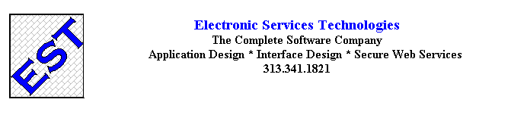

Images Below Represent the Workflow Required to Retrieve a Document from a FHIR Server.

Image 1

Represents Main Screen After Website Login

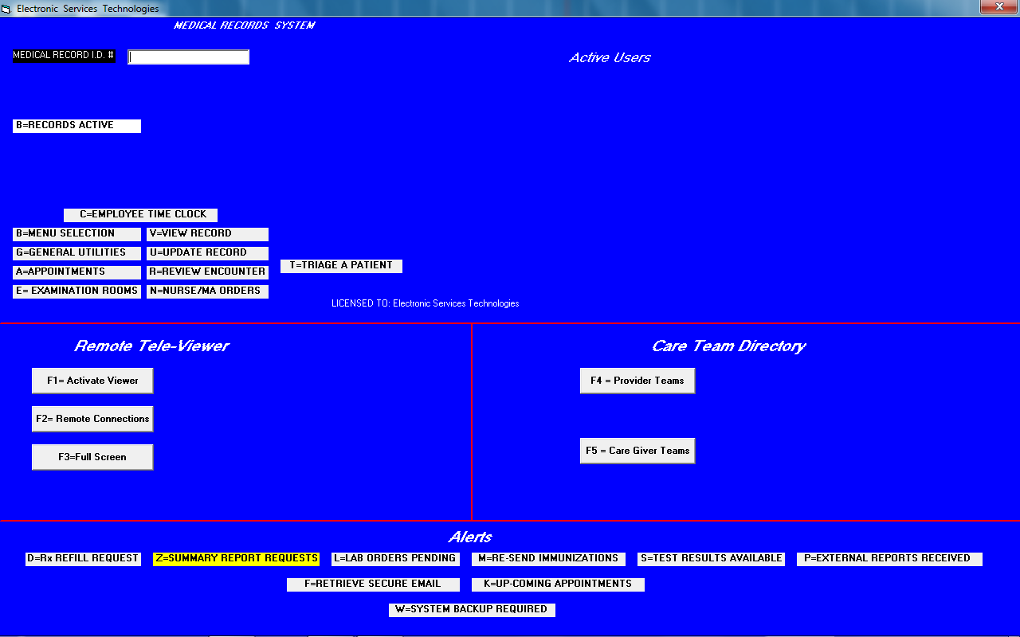

Image II

Represents Audit Login request for Patient Record Entry

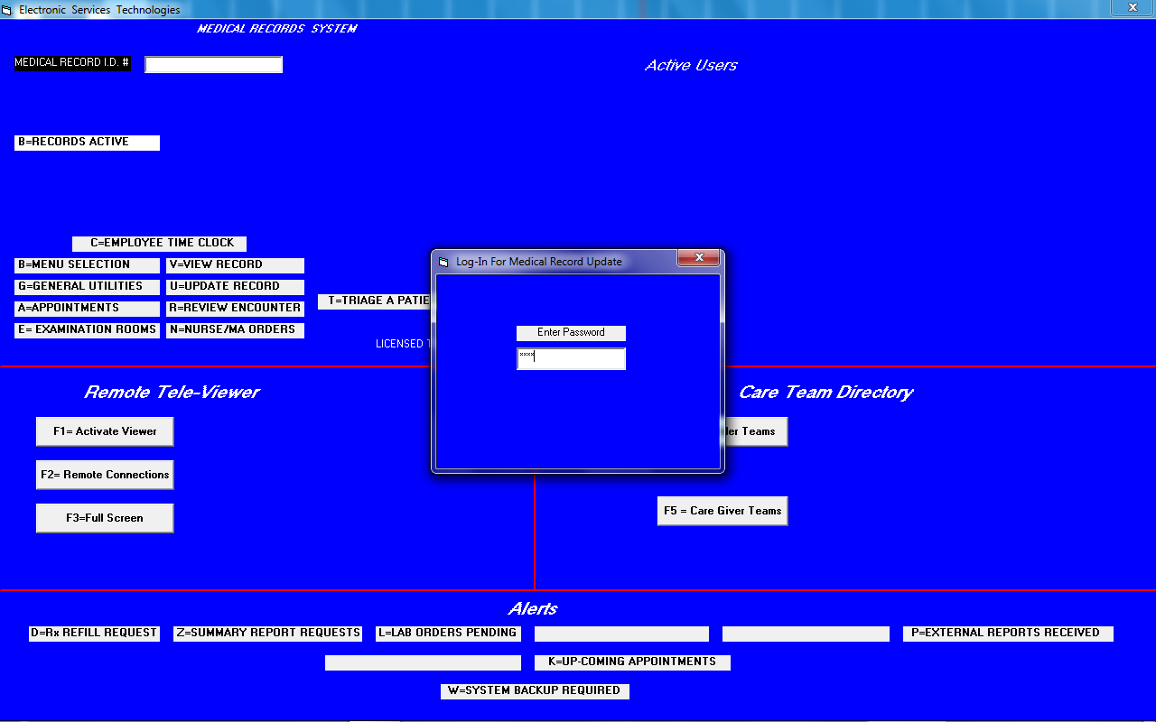

Image III

Represents Patient Selection for FHIR Document Search

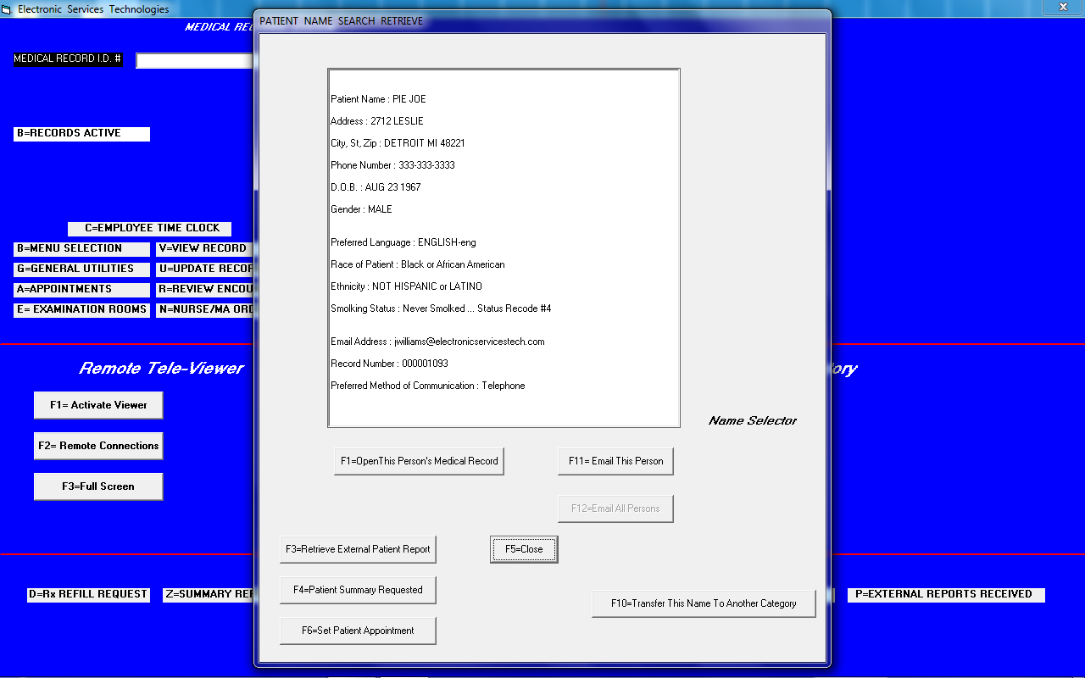

Image IV

Represents Selection of Document Type for Retrieval from FHIR Server

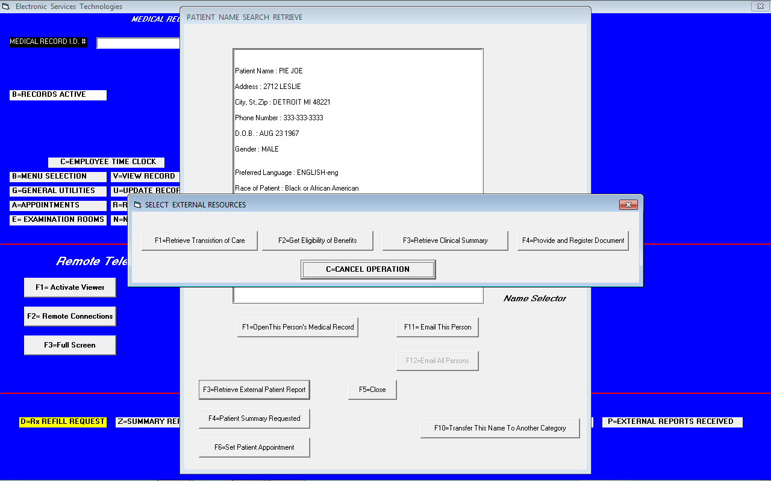

Image V

Represents Selection of FHIR Server that Acts as Repository for this Person (Provider) Look-Up

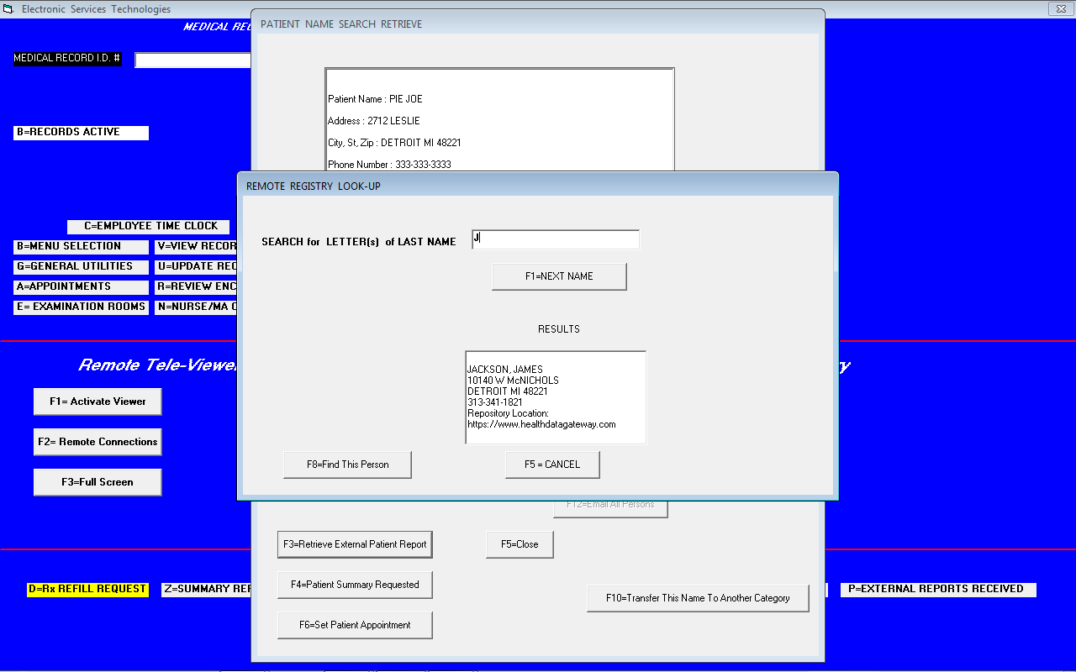

Image VI

Represents Request to Associate This Provider Repository with this Selected Patient.

(If User has previously lock-in this Provider then…this step is skipped and a submission started)

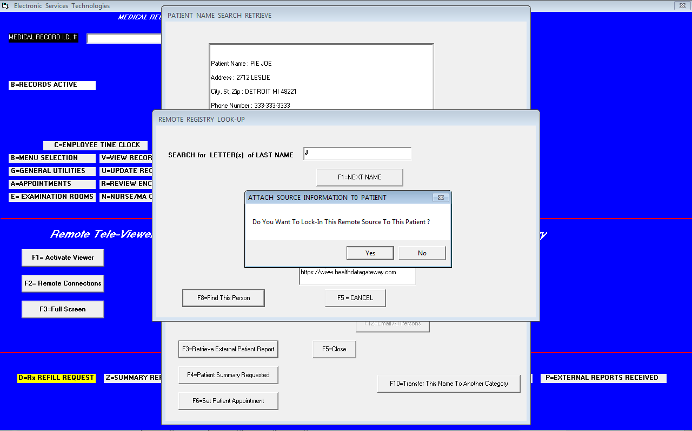

After the previous step, a Query (including User authentication information) is automatically generated for the selected FHIR Server and then sent.

… Now waiting for Retrieved Document

NOTE: This Portion in Red is transparent to the User.

Because the authentication credentials of the User, for this FHIR Service, were included in the generated Query, an automated Request and Document retrieve is initiated.

i.e. The Query will be redirected to an OAuth2 Server for authorization. Once an Authorization Token is obtained, our Application will re-present to FHIR Server and retrieve requested document.

If the FHIR Server does not support Automated Mode then our embedded Browser will activate and navigate to the FHIR Server for User manual input to authenticate.

Image VII

Represents Document Retrieved from FHIR Server … Process Completed !

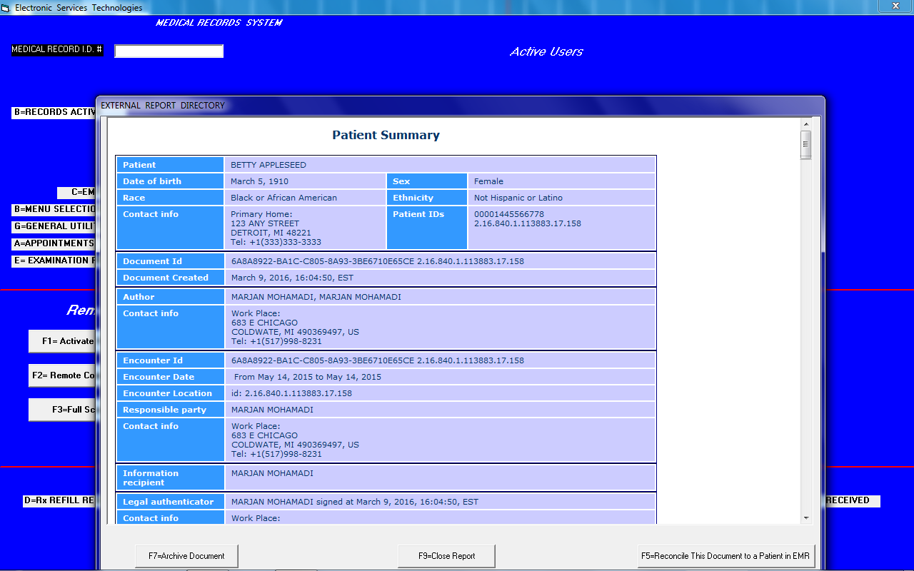

Image VIII

Represents the Loading Process of the FHIR Server Look-Up Directory

(Not used in Document Retrieve workflow)

